**EXPERIMENT- 1**

**Aim:**

Study of UNIX general purpose utility command list (man, who, cat, cd, cp, ps, ls, mv, rm, mkdir, rmdir, echo, more, date, time, kill, history, chmod, chown, finger, pwd, cal, logout, shutdown)

1. **man command:** It displays the whole manual of the command.

$ man [COMMAND NAME]

**I/P:**



**O/P:**

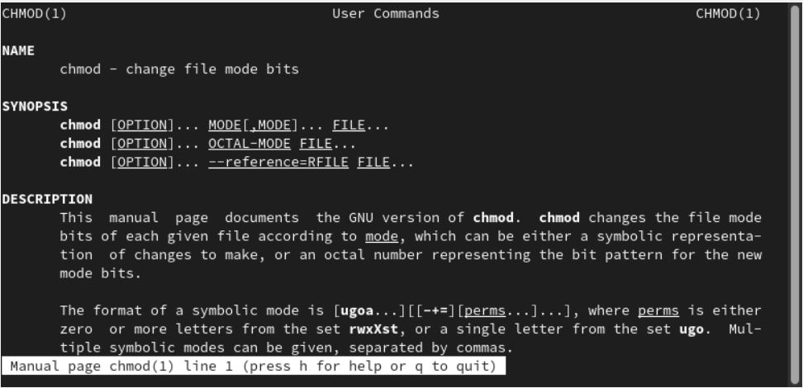

1. **who command: who** command is used to find out the following information:  
   1. List of logged in users   
   2. Time of last system boot   
   3. Current run level of the system and more.

$who [options] [filename]



1. **cat command:** It reads data from the file and gives their content as output. It helps us to create, view, concatenate files.

$cat filename

It will show content of given filename

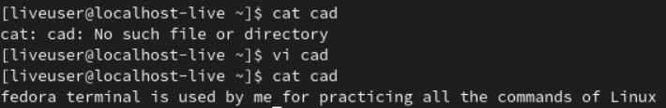

1. **cd Command:** It is used to change current working directory.

**$ cd [directory]**

**To move inside a subdirectory:** to move inside a subdirectory in Linux we use **cd ..**

This command is used to move to the parent directory of current directory, or the directory one level up from the current directory. “..” represents parent directory.

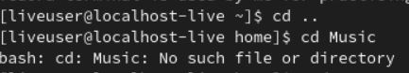

1. **cp command: cp** stands for **copy**. This command is used to copy files or group of files or directory. It creates an exact image of a file on a disk with different file name. cp command requires at least two filenames in its arguments.

**$ cp [OPTION] Source Destination**

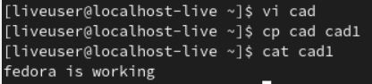

1. **ps command: ps** stands for Process status. It is used for viewing the information related with the processes on a system. ps command is used to list the currently running processes and their PIDs along with some other information depends on different options.

**$ ps [options]**

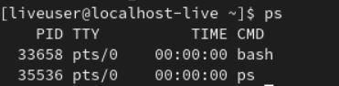

1. **ls command: ls** is a Linux shell command that lists directory contents of files and directories. It will show all the files including the ‘.’ (current directory) and ‘..’ (parent directory).



1. **mv command: mv** stands for **move**. mv is used to move one or more files or directories from one place to another in a file system like UNIX. It has two distinct functions:   
   **(i)** It renames a file or folder.   
   **(ii)** It moves a group of files to a different directory.

**$ mv [Option] source destination**

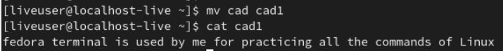

1. **rm command: rm** stands for **remove** here. rm command is used to remove objects such as files, directories, symbolic links and so on from the file system like UNIX.

**$ rm [OPTION]... FILE...**

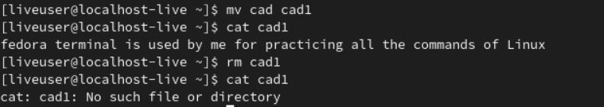

1. **mkdir command: mkdir** command in Linux allows the user to create directories. This command can create multiple directories at once as well as set the permissions for the directories.

$ mkdir [options...] [directories ...]



1. **rmdir command: rmdir** command is used remove empty directories from the filesystem in Linux. The rmdir command removes each and every directory specified in the command line only if these directories are empty.

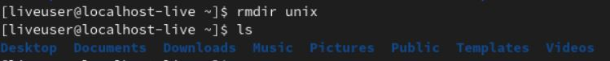

1. **echo command: echo** command in linux is used to display line of text/string that are passed as an argument. This is a built in command that is mostly used in shell scripts and batch files to output status text to the screen or a file.

**$ echo [option] [string]**



1. **more command:** The more command also allows the user do scroll up and down through the page.
2. **date command: date**command is used to display the system date and time. date command is also used to set date and time of the system.

$ date



1. **time command: time** command in Linux is used to execute a command and prints a summary of real-time, user CPU time and system CPU time spent by executing a command when it terminates.

$ time [option] [COMMAND]

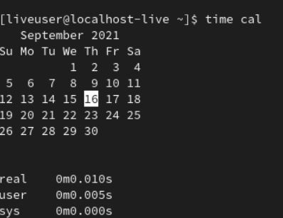

1. **kill command: kill** command sends a signal to a process which terminates the process.
2. **history command: history** command is used to view the previously executed command.

$ history

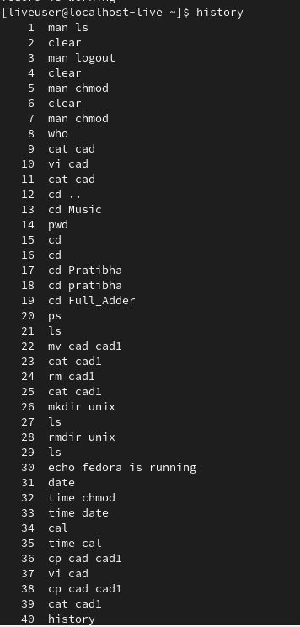

1. **Chmod command:** In Unix-like operating systems, the **chmod** command is used to change the access mode of a file. The name is an abbreviation of **change mode**.

$ chmod [reference][operator][mode] file...

Before Changing the user preference:

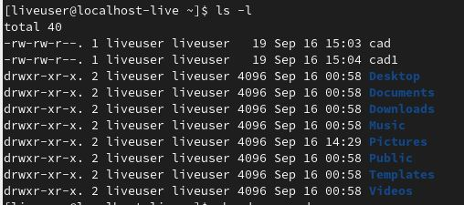

After Changing the user Preference:

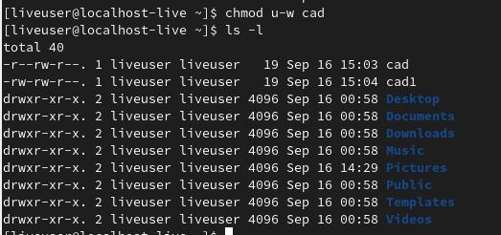

1. **chown command: chown** command is used to change the file Owner or group. Whenever you want to change ownership you can use chown command.

$ chown owner_name file_name

1. **finger command: Finger** command is a user information lookup command which gives details of all the users logged in. This tool is generally used by system administrators. It provides details like login name, user name, idle time, login time, and in some cases their email address even.

$finger user

1. **pwd command: pwd** stands for **P**rint **W**orking **D**irectory. It prints the path of the working directory, starting from the root. pwd is shell built-in command(pwd) or an actual binary(/bin/pwd).



1. **cal command: cal** command is a calendar command in Linux which is used to see the calendar of a specific month or a whole year.

$ cal [ [ month] year]

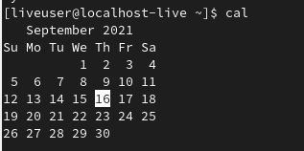

1. **logout command:**

**logout command** – Logout of a login shell. This command can be used by normal users to end their own session. $ logouts

1. **Shutdown command:**

The **shutdown** command in Linux is used to shutdown the system in a safe way. You can shutdown the machine immediately, or schedule a shutdown using 24 hour format.

$ shutdown [OPTIONS] [TIME] [MESSAGE]



1. **Print List of File Created**

